PROGRAM 7 : Retail Order Dispatch and Return Analysis

. Problem statement
A retail store receives customer orders and dispatches products from its inventory. Some products may be returned by customers, while some orders may remain partially fulfilled. Develop a Python program that processes order quantities, dispatch records, and returned quantities to calculate outstanding orders, update inventory correctly, and identify inconsistent records.
2. Objectives
- Store order quantities, dispatched quantities, and returned quantities.
- Calculate outstanding quantities for each order.
- Update inventory based on dispatches and returns.
- Detect inconsistent records, such as dispatches exceeding orders or returns exceeding dispatches.
- Generate a summary report for all orders.
3. Assumptions and rules
For this example, the store sells three products: laptops, headphones, and keyboards.
Product | Initial stock | Ordered | Dispatched | Returned
Laptop | 20 | 10 | 8 | 1
Headphones | 30 | 12 | 12 | 2
Keyboard | 15 | 8 | 5 | 0
Rules used:
- Outstanding quantity = Ordered quantity − Dispatched quantity.
- Returned products are added back to inventory, assuming they are suitable for resale.
- Final inventory = Initial stock − Dispatched quantity + Returned quantity.
- A dispatch exceeding the order quantity is inconsistent.
- A return exceeding the dispatched quantity is inconsistent.
- Negative quantities are invalid.
These are simplified assignment rules. The program will flag inconsistent records and avoid updating inventory for those records.
4. Computational thinking
- Decomposition: Divide the problem into order processing, dispatch validation, return validation, inventory updates, and report generation.
- Pattern recognition: Identify repeated errors such as dispatch quantities greater than orders and returns greater than dispatches.
- Abstraction: Focus on the product name and four quantities: stock, ordered, dispatched, and returned.
- Algorithmic thinking: Validate records first, calculate outstanding quantities for valid records, and update inventory only when the record passes the checks.
5. Algorithm
- Start the program.
- Store order records as tuples in a list.
- Initialize counters for valid and inconsistent records.
- Process each order record using a loop.
- Check whether any quantity is negative.
- Check whether the dispatched quantity exceeds the ordered quantity.
- Check whether the returned quantity exceeds the dispatched quantity.
- If the record is inconsistent, report the errors and do not update its inventory.
- Otherwise, calculate outstanding orders and final inventory.
- Display order details and a summary.
- Stop the program.
6. Flowchart
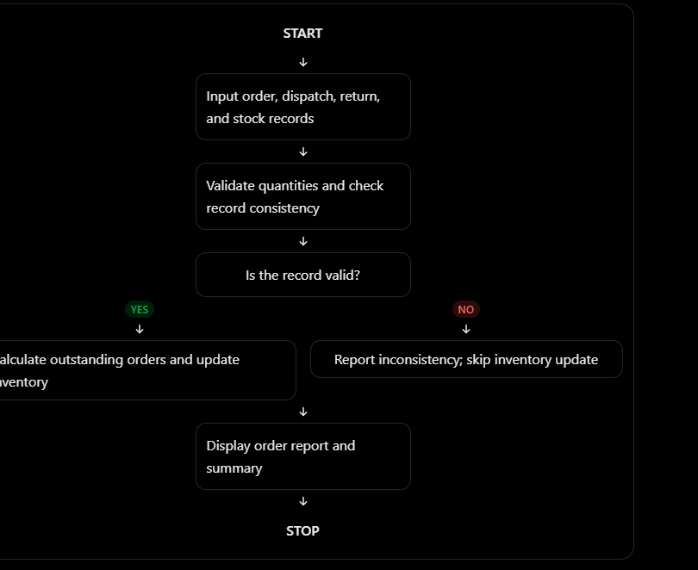
7.PSESUDO CODE
START

Store order records

FOR each record
Read product, stock, ordered, dispatched, returned
Set errors to an empty list

IF any quantity is negative
Add negative quantity error
END IF

IF dispatched > ordered
Add dispatch exceeds order error
END IF

IF returned > dispatched
Add return exceeds dispatch error
END IF

IF errors exist
Display errors
Do not update inventory
ELSE
outstanding = ordered - dispatched
final_stock = stock - dispatched + returned
Display order and inventory details
END IF
END FOR

Display summary totals

STOP

8.PYTHON SOURCE CODE

# Retail Order Dispatch and Return Analysis

# Each tuple contains:
# (Product, Initial Stock, Ordered, Dispatched, Returned)

orders = [
("Laptop", 20, 10, 8, 1),
("Headphones", 30, 12, 12, 2),
("Keyboard", 15, 8, 5, 0),
("Mouse", 25, 6, 8, 9) # Inconsistent record
]

valid_records = 0
invalid_records = 0
total_outstanding = 0
inventory = {}

print("===== RETAIL ORDER ANALYSIS =====")

for record in orders:
product, stock, ordered, dispatched, returned = record

errors = []

# Check for negative quantities
if stock < 0 or ordered < 0 or dispatched < 0 or returned < 0:
errors.append("Negative quantity found")

# Check dispatch quantity
if dispatched > ordered:
errors.append("Dispatch exceeds ordered quantity")

# Check return quantity
if returned > dispatched:
errors.append("Return exceeds dispatched quantity")

print("\nProduct:", product)

if errors:
invalid_records += 1

print("Status: INCONSISTENT")
for error in errors:
print("Error:", error)

print("Inventory update: Skipped")

else:
valid_records += 1

# Calculate outstanding order quantity
outstanding = ordered - dispatched

# Update inventory after dispatches and returns
final_stock = stock - dispatched + returned

inventory[product] = final_stock
total_outstanding += outstanding

print("Ordered:", ordered)
print("Dispatched:", dispatched)
print("Returned:", returned)
print("Outstanding:", outstanding)
print("Final inventory:", final_stock)
print("Status: VALID")

# Display summary
print("\n===== SUMMARY =====")
print("Total records:", len(orders))
print("Valid records:", valid_records)
print("Inconsistent records:", invalid_records)
print("Total outstanding orders:", total_outstanding)

print("\nFinal inventory of valid records:")
for product, quantity in inventory.items():
print(product, ":", quantity)

print("\nAnalysis completed.")

9. Test cases
Test case | Input condition | Expected result
1 | Ordered 10, dispatched 8, returned 1 | Outstanding = 2; final stock = initial stock − 7
2 | Ordered 12, dispatched 12, returned 2 | Outstanding = 0; returned stock is added
3 | Ordered 6, dispatched 8 | Flag dispatch exceeding order
4 | Dispatched 5, returned 6 | Flag return exceeding dispatch
5 | Any quantity is negative | Flag a negative quantity
10. Expected output
===== RETAIL ORDER ANALYSIS =====

Product: Laptop
Ordered: 10
Dispatched: 8
Returned: 1
Outstanding: 2
Final inventory: 13
Status: VALID

Product: Headphones
Ordered: 12
Dispatched: 12
Returned: 2
Outstanding: 0
Final inventory: 20
Status: VALID

Product: Keyboard
Ordered: 8
Dispatched: 5
Returned: 0
Outstanding: 3
Final inventory: 10
Status: VALID

Product: Mouse
Status: INCONSISTENT
Error: Dispatch exceeds ordered quantity
Error: Return exceeds dispatched quantity
Inventory update: Skipped

===== SUMMARY =====
Total records: 4
Valid records: 3
Inconsistent records: 1
Total outstanding orders: 5

Final inventory of valid records:
Laptop : 13
Headphones : 20
Keyboard : 10

Analysis completed.

11. Conclusion
The program analyzes retail orders, calculates outstanding quantities, updates inventory for valid records, and identifies inconsistent dispatch or return information. Skipping inventory updates for invalid records helps prevent incorrect stock calculations.

